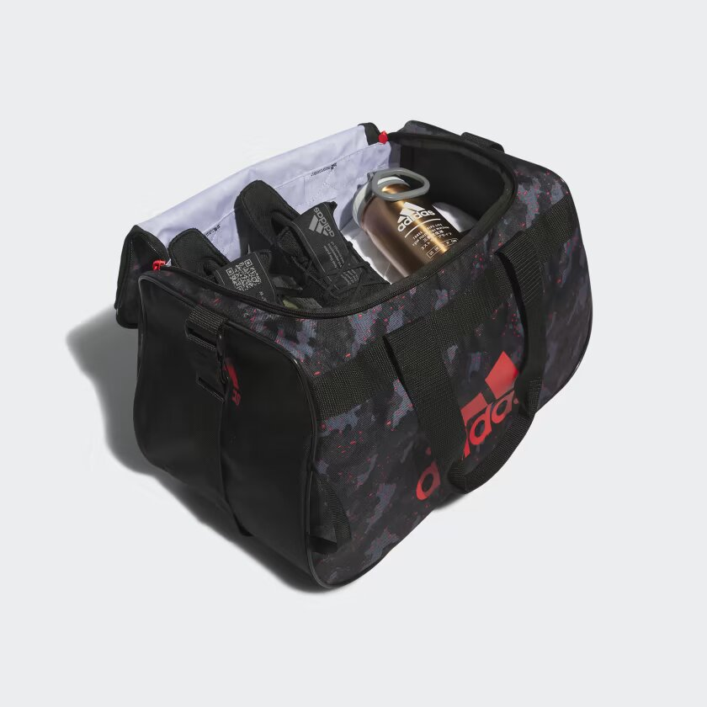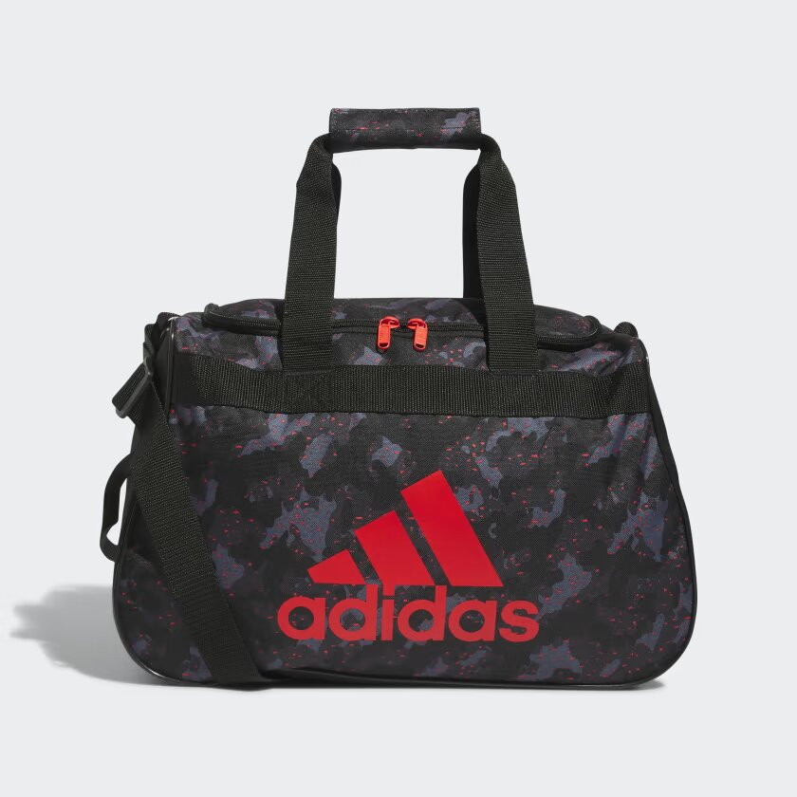

ADIDAS DIABLO SMALL DUFFEL BAG

The perfect size bag to cover you for gym or school. With a zippered main compartment that opens wide for easy packing. The shoulder strap is adjustable so you can wear it at the length you like and the haul handle is padded for comfort.

**DETAILS:**

* Imported
* Galaxy Camo
* Product color: Black / Bright Red
* Product code: GC3531